**VOYAGE VISTA: ILLUMINATING INSIGHTS FROM UBER EXPEDITIONARY ANALYSIS**



1. INTRODUCTION

* 1. **Overview**
* UBER Driver Analysis refers to the Analyzing the number of trips taken by UBER drivers can provide insights into their overall activity and the demand for rides in specific areas.
* UBER’ S data can be analyzed on a daily, weekly, monthly basis to understand the trends and patterns of trip volumes.
* The Major of our project is to use data Analysis techniques to find unknown patterns in the UBER Drives dataset.
  1. **Purpose**
* The Major of our project is used to Tableau, Data Literacy, Data Analysis, Data Preparation, Business Intelligence and Data Visualization.

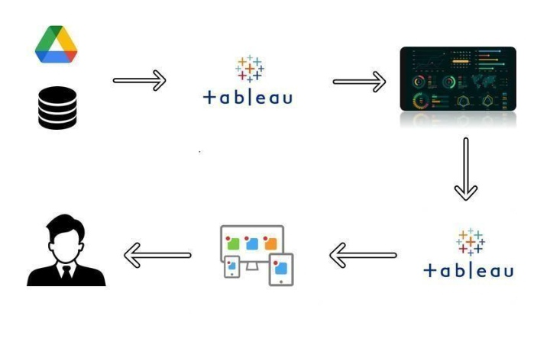**2. Problem Definition & Design Thinking**

* 1. **Empathy Map**

* An empathy map is a collaborative tool teams can use to gain a deeper insight into their customers.
* An empathy map is a simple easy to digest visual that capture knowledge about a user behaviors and attitude.

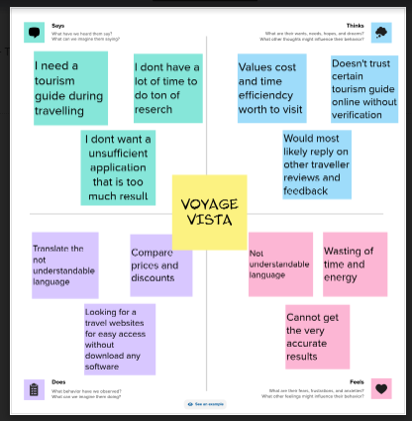

* 1. **ideation & Brainstorming Map**
* Brainstorming is a group problem-solving method that involves the spontaneous contribution of creative ideas and solutions.
* This technique requires intensive, freewheeling discussion in which every member of the group is encouraged to think aloud and suggest as many ideas as possible based on their diverse knowledge.

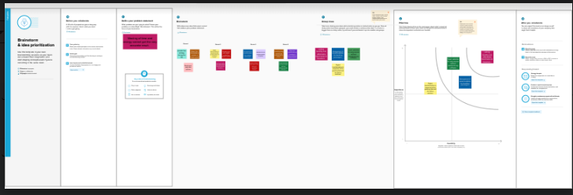

3. RESULT

* **Final findings(OUTPUT)**

**1. COLLECT THE DATASET**

**2. CONNECT DATASET WITH TABLEAU**

* **COLLECT THE DATASET**
* A data set is an ordered collection of data.
* **CONNECT DATASET WITH TABLEAU**
* Start tableau desktop and on the connect pane
* The under search for data, select tableau server
* To connect to tableau server, enter the name of the server and the select connect.

1. **DATA PREPARATION**

* The data of preparation is the placing into final solution before freeze drying.
* The data of preparation is the data of heat treatment in the final container.

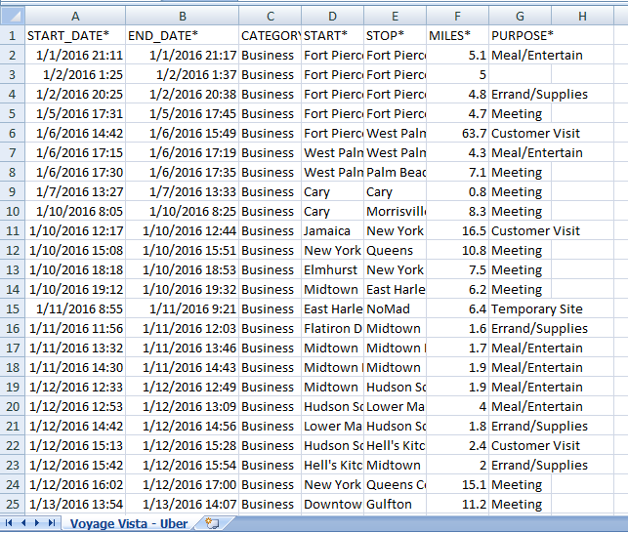

1. **DATA VISUALIZATION**

* **We introduced graphical representation of any data or information**
* Visuals are more effective then text
* Visualized data increases knowledge
* Visual metaphors are a universal language
* People of any spoken are written language can communicate with visual metaphors
* Data has value only when it is processed, analyzed and remembered
* **Use this subheading to give graphical representation of data**
* **Graphical representation like bar chart, pie chart line chart and maps.**

1. **DASHBOARD**

* The correct use of dashboard UX and graphical excellence principles turn ordinary graphical into extraordinary experiences.

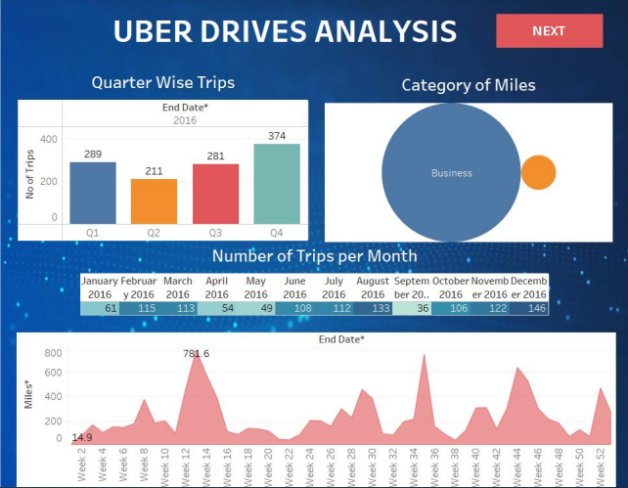

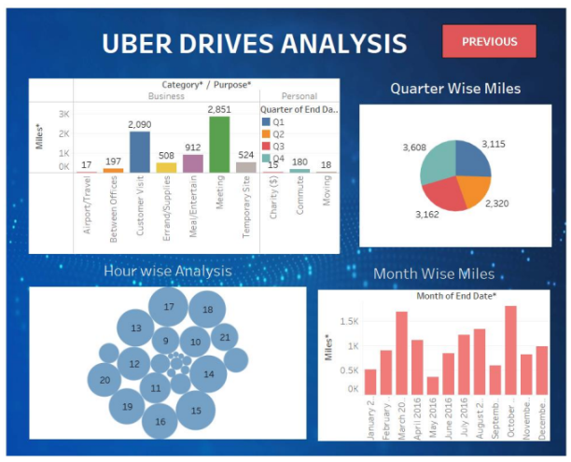

1. **STORY**

* A data story is a narrative constructed around a set of data that puts it into context and frames the broader implication.
* A data stories can be told using a variety of mediums, such as reports, interactive and videos.

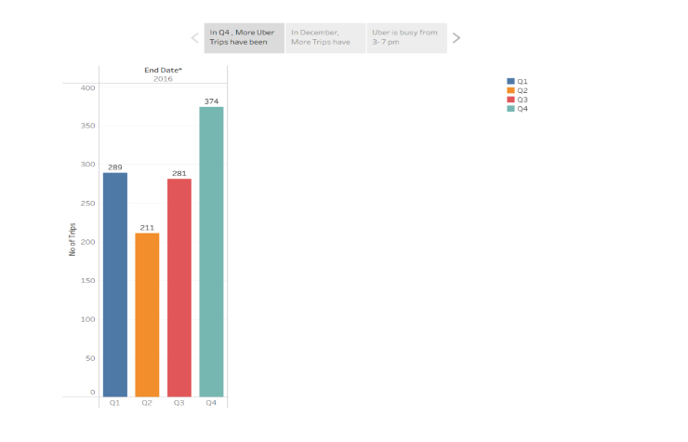

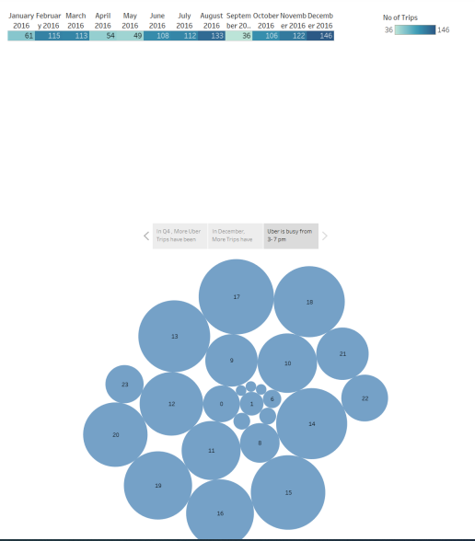

**4. ADVANTAGES & DISADVANTAGES**

* **Advantages :**
* This method of communication is entirely accurate since it is open for verification and it is also for authentication.
* For specific areas like organizational objectives, rules, and regulations, only written communication is effective.
* Written communication can be preserved for a long time, and if needed in the future, it can be used as a legal document.
* **Disadvantages :**
* In this method of communication, the feedback procedure is quite delayed.
* This method of communication has a limited reach since it can only be accessed by education people and not by uneducated people.

**5. APPLICATION**

* Solution is used to transport apps and components from one environment to another or to apply a set of a customization to existing apps.
* A solution the mechanism for implementing application lifecycle management in power apps and other power platform products, such as power automate.

1. **CONCLUSION**

* One clear outcome of this journey does not matter where you are in the world or how far along the road to peace you are, social identities are integral to our lives.
* As such, we believe that our journey does not end with this conclusion.

1. **FUTURE SCOPE**

* Tourism sector has created about 11 million jobs and has the potential to create another 37 million jobs in the future.
* Although the future of the industry is quite bright but still there is a lot of development in term of infrastructure and skilled personnel.

1. **APPENDIX**

* **Source Code**

**DATASET:**

**[https://drive.google.com/file/d/1TG3xoPJKnG19EuX6hV1c-_ _YW-7/view](https://drive.google.com/file/d/1TG3xoPJKnG19EuX6hV1c-_mjKF0_YW-7/view)**

**DASHBOARD 1:** [**https://public.tableau.com/app/profile/t.jenita/viz/DASHBOARD1_16969256370250/Dashboard1**](https://public.tableau.com/app/profile/t.jenita/viz/DASHBOARD1_16969256370250/Dashboard1)

**DASHBOARD 2:** [**https://public.tableau.com/app/profile/t.jenita/viz/DASHBOARD2_16969259477670/Dashboard2**](https://public.tableau.com/app/profile/t.jenita/viz/DASHBOARD2_16969259477670/Dashboard2)

**STORY:** [**https://public.tableau.com/app/profile/t.jenita/viz/STORY1_16969261515860/Story1**](https://public.tableau.com/app/profile/t.jenita/viz/STORY1_16969261515860/Story1)